|  |
| --- |
| *Technical Design Specification* |

|  |  |  |  |
| --- | --- | --- | --- |
|  | Name | Role | Date |
| Author | Raju Lakide | ABAP Technical Consultant | 29-04-2025 |
| Reviewer |  |  |  |

Contents

Index of Changes 3

1. Purpose and objective 4

2. Type of Specification 4

3. Document References 4

4. Technical Design 4

4.1. Technical Design Summary 4

4.2. Data Dictionary 4

4.3. Transaction 4

4.4. Classes 5

4.5. BadI 5

4.6. Other Kind of development 6

4.7. Error Condition Handling 6

4.8. Additional Information 6

Index of Changes

|  |  |  |  |
| --- | --- | --- | --- |
| Date | Version | Description of Change | Author |
| 29-APR-2025 | 2.0 | Based on the requirement implement the lumpsum billing(price approval) in SD process | Raju L |
|  |  |  |  |
|  |  |  |  |

# Purpose and objective

# This document describes the technial specification for the correction for code land data

# Type of Specification

|  |  |
| --- | --- |
| Program type: | Report (read only)  Update function    Utility  Enhancement (user-exit, BADI, function module)  Modification  SAP GUI Dynpro  Web Dynpro  Interface  Inbound  Outbound  BW extractor |

# Document References

|  |  |  |  |
| --- | --- | --- | --- |
| Ref. | Document Name | Version | Remarks |
|  |  |  |  |

# Technical Design

Technical Design Summary

**Decommission event.**

Business needs to implement the lumpsum billing in SD process

**Updated Logic:**

Step1: Based on the requirement added lumpsum field in ZV12

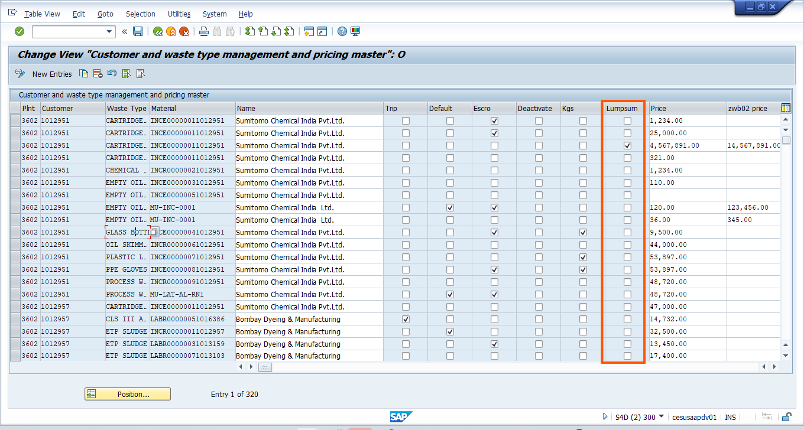

Step2: Added lumpsum field in ZIWM_PRICE output

In ALV output check the filed lumpsum as X and save 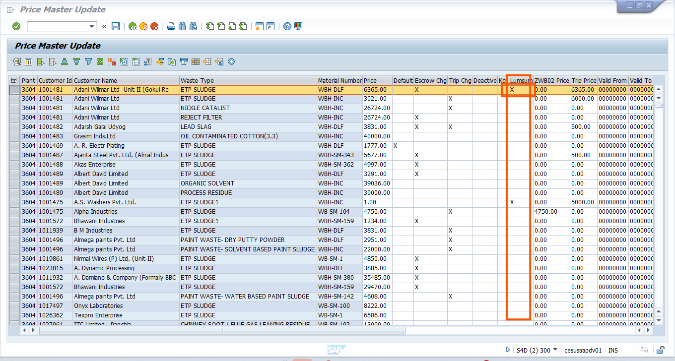

When click on save the data will be store into respective tables and mail will be trigger to the respected persons

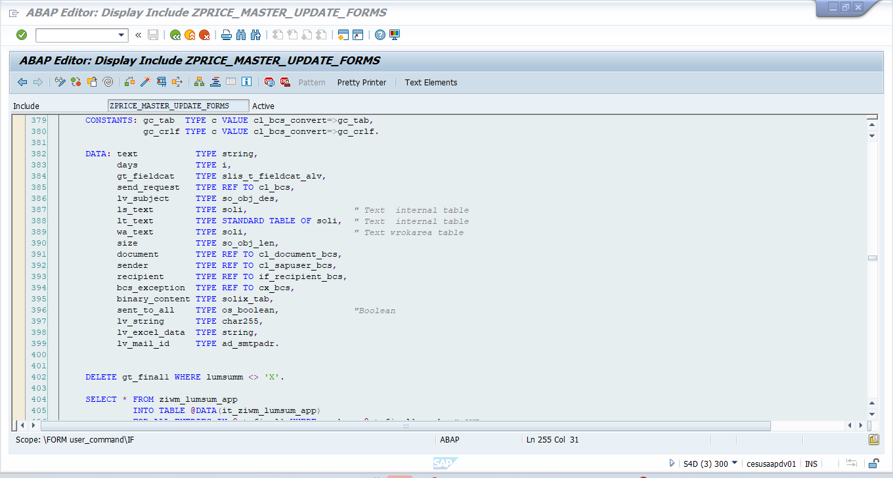

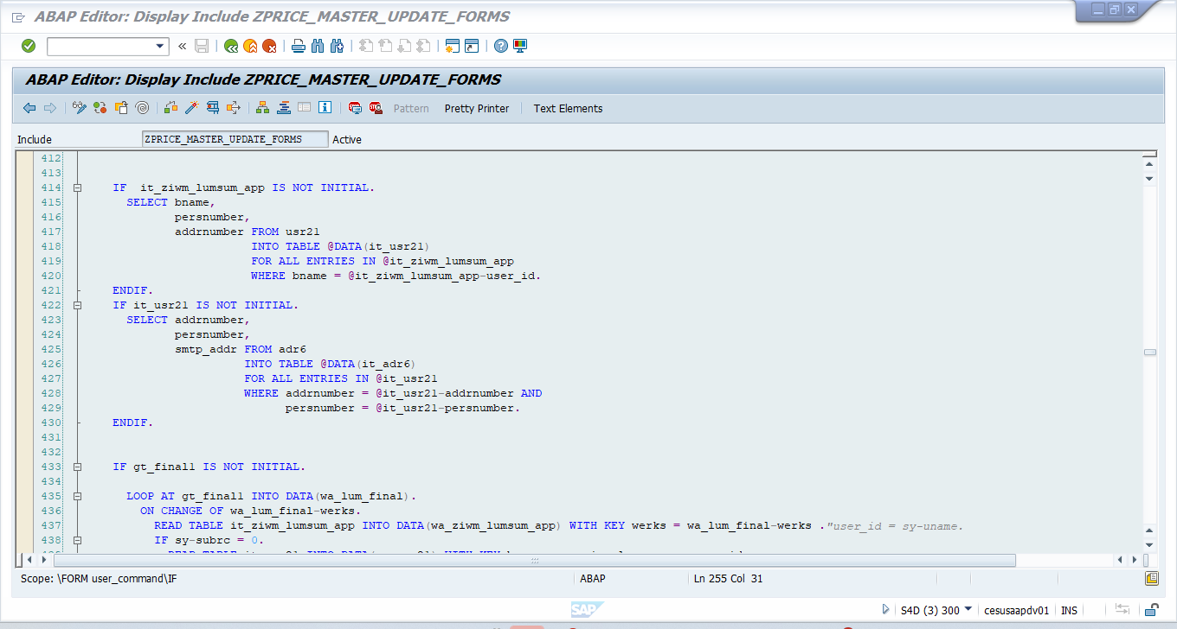

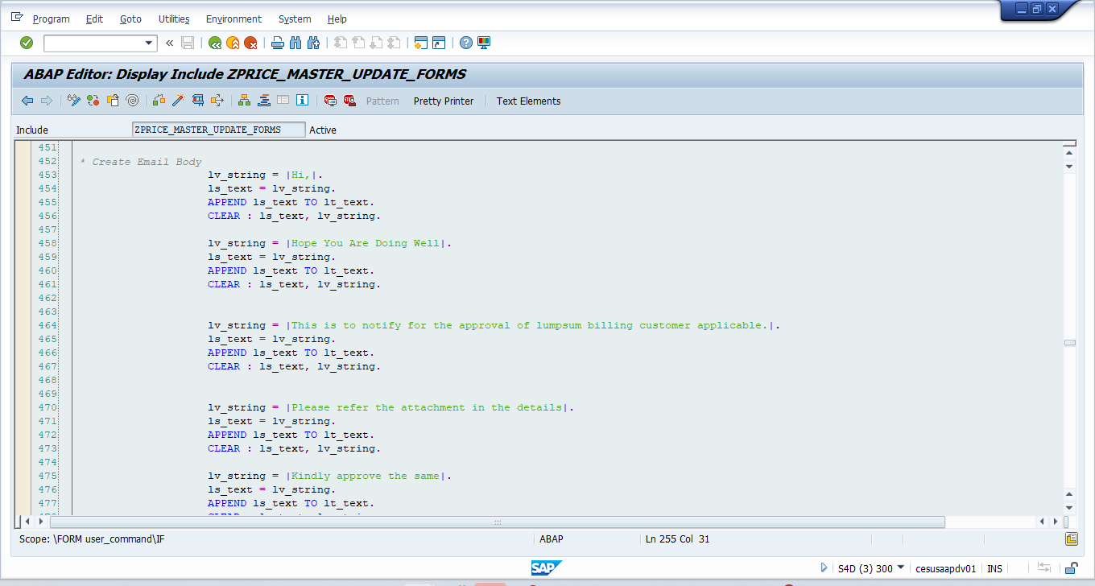

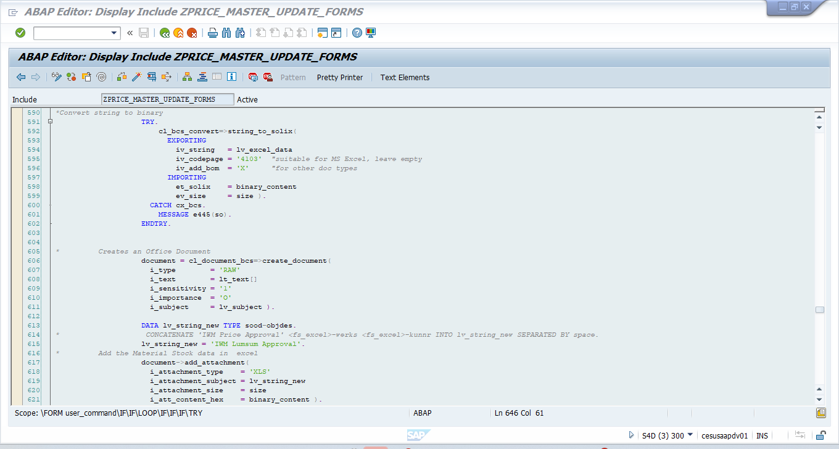

Step3: Go to transaction ZIWM_APPROVE and execute

Select the record and save once the data will be save it is updated into ZV12

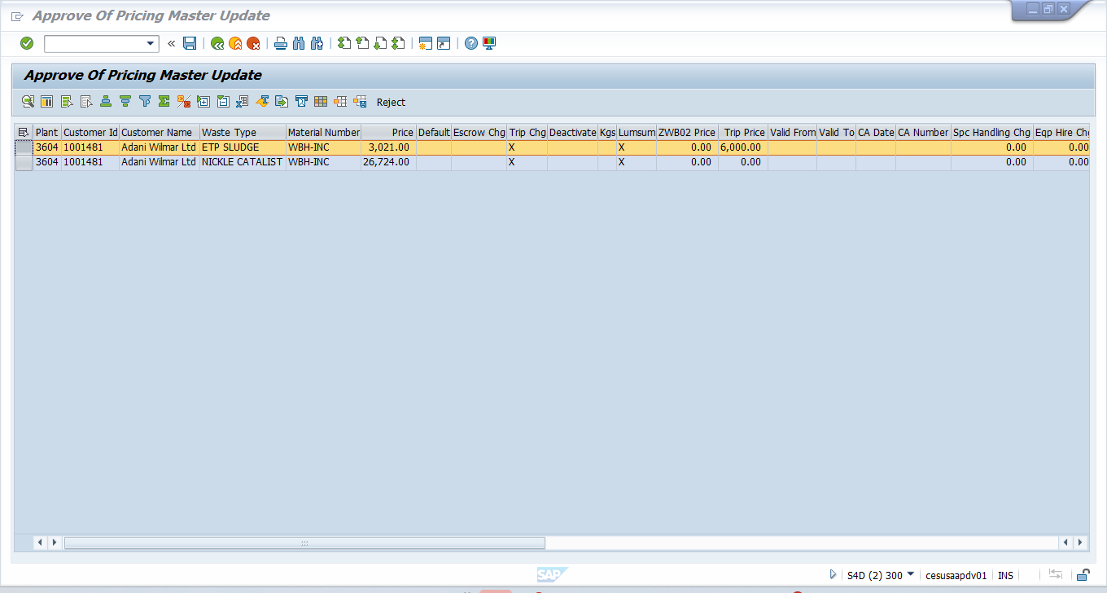

If you click on reject button the data will not save and trigger the mail for respected persons

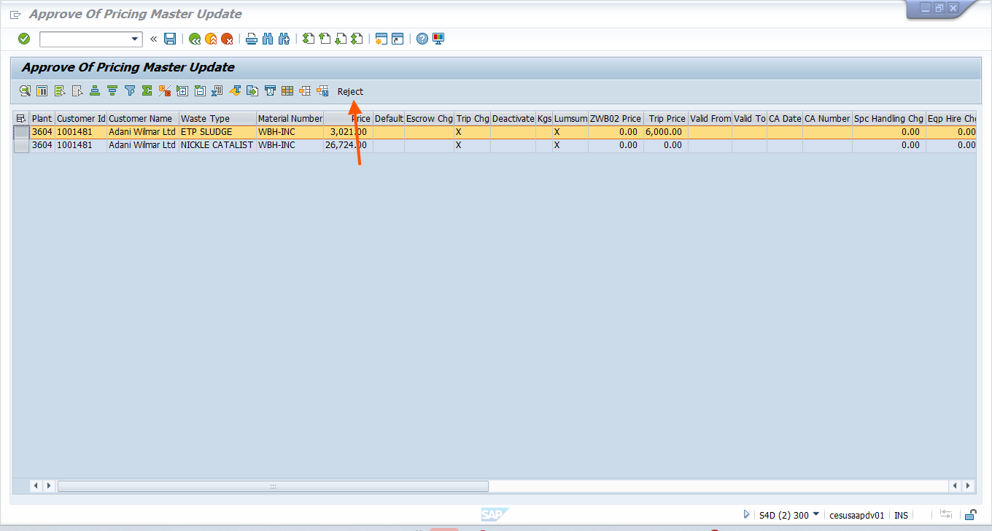

Data Dictionary

n/a

Transaction

**ZV12**

**ZIWM_PRICE**

**ZIWM_APPROCE**

Classes

n/a

BadI

n/a

Other Kind of development

n/a

Error Condition Handling

n/a

Additional Information

n/a